# NFC

## NFC overview

Near field communication (NFC) is a set of standards for smartphones and similar devices to establish radio communication with each other by touching them together or bringing them into close proximity, usually no more than a few centimeters. Present and anticipated applications include contactless transactions, data exchange, and simplified setup of more complex communications such as Wi-Fi. Communication is also possible between an NFC device and an unpowered NFC chip, called a "tag"

NFC technology is applied to many fields in many countries. NFC devices can be used in contactless payment systems and allow mobile payment to replace or supplement these systems. NFC offers a low-speed connection with extremely simple setup, and can be used to bootstrap more capable wireless connections. Besides, NFC can be used in social networking situations, such as sharing contacts, photos, videos or files, and entering multiplayer mobile games. It is possible to The NFC Forum promotes the potential for NFC-enabled devices to act as electronic identity documents and keycards…

## NFC development in PFM system

### NFC technology in PFM system

PFM system uses NFC technology to read payloads of data from an NFC tag. The NFC tag will store product information including name, price… From this information, PFM system will parse to records and save them to PFM database.

### NFC development

To handle NFC technology for our specified case, we follow below steps:

* Detect an NFC tag.
* Read data from NFC tag.
* Parse data to an object and save them to local database.

#### Detect an NFC tag

When users touch an NFC tag to their device, Android-powered device is usually looking for NFC tags when the screen is unlocked, unless NFC is disabled in the device's Settings menu. When an Android-powered device discovers an NFC tag, it should launch PFM system as default behavior. In PFM system, we defined a class to detect that NFC and give its content to an activity to resolve.

#### Read data from NFC tag

If NFC detector works correctly, then our activity should get all content of NFC tag for its intent.

#### Parse data to an object and save them to local database

PFM system will parse raw data that are got from NFC tag to objects and then save it to local database if user needs.

# Synchronization

## Synchronization in PFM system

PFM system will support below features for synchronization function:

* Synchronize all user’s data with an existed email account
* Synchronize data with multi-account
* Synchronize data to multi-device
* Automatically synchronization mode

## Synchronization implementation

* + 1. Flow diagram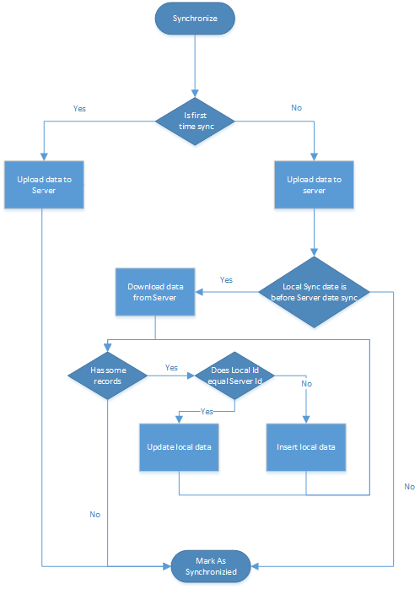

# QR Code

# Chart